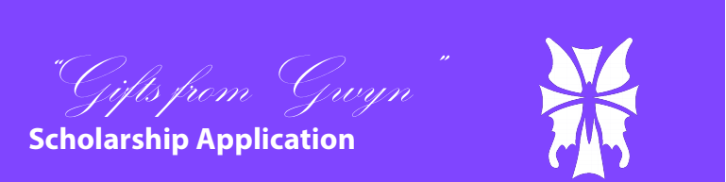

Name ________________________________
Male ___ Female ___
Address ________________________________________________
_______________________________________________________
Home Phone ____________________________________________
Email __________________________________________________
Father/Guardian ______________________________________
Occupation __________________________________________
Father’s Address ______________________________________
Father’s Email ________________________________________
Mother/Guardian ______________________________________
Occupation ___________________________________________
Mother’s Address ______________________________________
Mother’s Email ________________________________________
“Gifts from Gwyn” Scholarship Guidelines
Eligibility
Open to all current students in grades 9-12 at CEC (2026, 2027, 2028, and 2029).
Student must be in good academic and disciplinary standing.
Criteria
Students may submit an art piece inspired by the theme “Friendship” or “Random Acts of Kindness”
Pieces may be submitted in the form of a poem, drawing, video, or song
Value
The award is a $1,000.00 one-year scholarship that is applied directly to tuition.
Selection
Selection of the scholarship award will be determined by the Rivells family and any members of a committee chosen by them
Deadline
All applications must be submitted to Conwell-Egan Catholic High School by December 15, 2025
How to Submit
Applications may be submitted in the Admissions Office or via email at mdelfin@conwell-egan.org
Acceptable Formats: USB drive, CD/DVD-ROM, Portfolio, JPG, PDF, .MOV, .MP4, .AVI, .WMV

